Automatic Number Plate Recognition

Project Synopsis

Members:

Rupam Ganguly GCECTB-L17-2006

Urmila Kewat GCECTB-R16-2037

Jamuna Majhi GCECTB-L-17-2002

**INTRODUCTION:**

Automatic recognition of license plate number became a very important in our daily life because of the unlimited increase of cars and transportation systems which make it impossible to be fully managed and monitored by humans, examples are so many like traffic monitoring, tracking stolen cars, managing parking toll, red-light violation enforcement, border and customs checkpoints. Yet it’s a very challenging problem, due to the diversity of plate formats, different scales, rotations and non-uniform illumination conditions during image acquisition.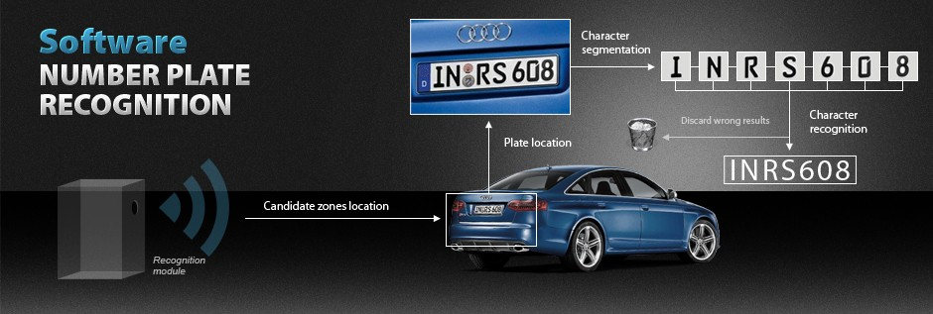

**OBJECTIVE:**

The process of automatic number plate recognition consists of four main stages:

1. **Number plate detection:**

Taking image as input, then applying ‘haar cascade’ that is pre-trained to detect Indian license plates, here the parameter scaleFactor stands for a value by which input image can be scaled for better detection of license plate

1. **Performing some image processing on the License plate:**

**Here we resize the Number Plate,** resizes it to a dimension such that all characters seem distinct and clear.

Then convert the coloured image to a grey scaled image i.e instead of 3 channels (BGR), the image only has a single 8-bit channel with values ranging from 0–255 where 0 corresponds to black and 255 corresponds to white.

Now the threshold function converts the grey scaled image to a binary image i.e each pixel will now have a value of 0 or 1 where 0 corresponds to black and 1 corresponds to white. It is done by applying a threshold that has a value between 0 and 255.

The image is now in binary form and ready for the next process Eroding.  
Eroding is a simple process used for removing unwanted pixels from the object’s boundary meaning pixels that should have a value of 0 but are having a value of 1.

The image is now clean and free of boundary noise, we will now dilate the image to fill up the absent pixels meaning pixels that should have a value of 1 but are having value 0.

1. **Character segmentation:**

Image segmentation can be defined as the segregation of pixels of interest for effective processing. The main aim of image segmentation is to segment the meaningful regions of interest for processing.

Active contour is one of the active models in segmentation techniques

Contour is an outline representing or bounding the shape or form of something.



After finding all the contours we consider them one by one and calculate the dimension of their respective bounding rectangle. Now consider bounding rectangle is the smallest rectangle possible that contains the contour. Let me illustrate the bounding rectangle by drawing them for each character here.



1. **Character recognition:**

The goal of this stage is to recognize and classify the binary images that contain characters received from the previous one. Here we use Neural Network that will be intelligent enough to recognize the characters after training.

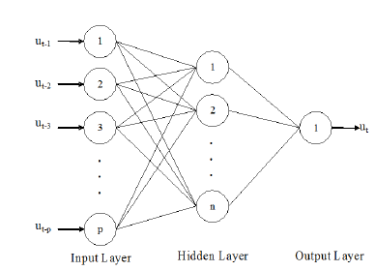

For modelling, we will be using a Convolutional Neural Network with 3 layers.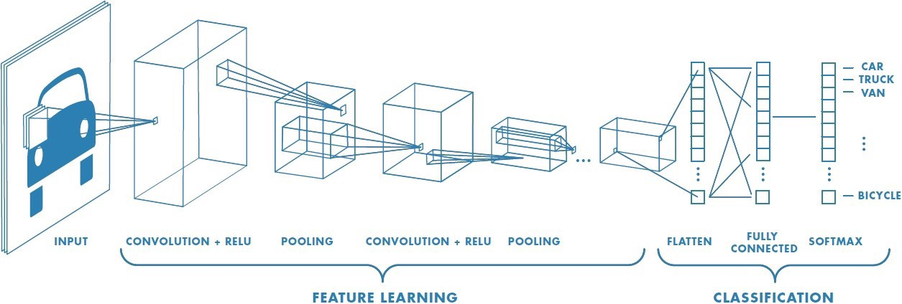

The first layer will be a convolutional layer with 32 output filters, a convolution window of size (5,5), and ‘Relu’ as activation function.

Next, we’ll be adding a max-pooling layer with a window size of (2,2). Now, we will be adding some dropout rate to take care of overfitting. Now it’s time to flatten the node data so we add a flatten layer for that. Flatten layer takes data from the previous layer and represents it in a single dimension.

Finally, we will be adding 2 dense layers, one with the dimensionality of the output space as 128, activation function=’relu’ and other, our final layer with 36 outputs for categorizing the 26 alphabets (A-Z) + 10 digits (0–9)

and activation function=’ softmax’

**Requirements:**

* Python 3.7.4 as programming language
* OpenCV Library for image manipulation
* TensorFlow – Keras for training the machine to recognition character form plate

**Conclusion:**

It is quite clear that ANPR is difficult system because of different number of phases and presently it is not possible to achieve 100% overall accuracy as each phase is dependent on previous phase. Certain factors like different illumination conditions, vehicle shadow and non-uniform size of license plate characters, different font and background colour affect the performance of ANPR.